Acid STIMULATION of CARBONATE RESERVOIR IN NORthEASTERN THAILAND
Vimontha Janbumrung* and Kriangkrai Trisarn
Running head: Acid Stimulation of Carbonate Reservoir in Northeastern Thailand
Abstract
The purpose of this study is to analyze production performance of well stimulation by acidizing and acid fracturing of northeastern gas reservoir using developed computer program to increase the permeability and improve in flow performance. The original permeability of reservoir is 0.5 md. with 5 production wells has the maximum gas production rate of 19.11 MMSCF/D. After acidizing, the permeability increases to be 1.75 md. and maximum gas production increase to be 20.77 MMSCF/D. After acid fracturing, the permeability increases to be 37.73x10⁹ md. and maximum gas production rate increases to be 228 MMSCF/D. The results of gas production performance from developed program and Eclipse show the closed results. The economic analysis result shows that after acid fracturing has completely paid back in the 6th year of production with internal rate of return at 34.49%. Acid stimulation program are advantage valuable data to use for decision-making in the investment of petroleum exploration in the northeastern Thailand. This is also useful to predict for the future petroleum exploration business in the northeastern Thailand.

Keywords: Well stimulation, Acidizing , Acid fracturing, Gas reservoir
Introduction
Petroleum is the most important energy that is closely involved with human activities. Recently natural gas is more necessarily required for transportation, petrochemical and electrical power generation that produces fundamental necessities of life. Now some gas fields are discovered in limestone in the northeast Thailand such as Nam Phong and Sin Phu Hom gas fields (Department mineral and fuels, 2006). Therefore well stimulation is an alternative method to increase production rate. Well stimulation techniques are applied on a regular basis to enhance productivity and maximize recovery in gas wells (Economide, 2000). In acidizing, the acid treatment is injected at pressures below formation fracturing pressure. In acid fracturing, all (or at least a significant portion) of acid treatment is intentionally pumped above formation fracturing pressure (Kalfayan, 2001). Among these techniques, the acidizing process leads to increased gas production rate and reserves, can be improving the ultimate recovery in carbonate reservoir.
The SGAD (Self gelling acid diverter) is currently used in stimulation process. If no diverter was injected, the stimulation length should be at least 11 times deeper for the height. It has a very low filtration rate and is very powerful to limit fluid loss from the fracture permeability core compared to the low permeability one (Bazin and Longeron, 2009 and Crowe, 1981). Al-Dahlan, Nasr-El-Din, and Saudi Aramco (2000) discussed a new technique that was used to evaluate matrix acid treatment. The technique relies on calculation amount minerals dissolved by the acid. It was used to calculate the volume of the produced spent acid and the amount of minerals (calcite and dolomite) that were dissolved by the acid. Reservoir efficiency determination by using the tank model is written by Trisarn (1987). Radial model of Trisarn was based on the geologic interpretations and the buildup analysis. This technique uses the variation of pressure and basic properties to evaluate reservoir efficiency.
The purpose of this study is to analyze production performance of well stimulation by acidizing and acid fracturing of northeastern gas reservoir using developed computer program to increase the permeability and improve in flow performance.

Data and Methods
Data
Required data for acid stimulation design consist of four major data, which are reservoir, fluid, well, and production data. Acid stimulation may be divided into two main classes as matrix acidizing and fracturing acidizing. Matrix acidizing involves the acid injection into the formation. Acid fracturing involves the high hydraulic pressure injection and the acid is forced into the formation to cause a fracture.
The developed computer program is divided into 3 parts: acidizing, acid fracturing, and reservoir efficiency. The required reservoir parameters are formation thickness (h), reservoir pressure, reservoir temperature, reservoir depth, original permeability, gas specific gravity, initial water saturation, porosity, fracture gradient, well radius (r_{w}), and reservoir radius (r_{e}).
The first matrix acidizing consists of acid type, spurt loss, acid concentration, acid density, acid viscosity, spending time, permeability in damaged zone, acidizing radius (r_{a}). The second acid fracturing consists of acid type, acid concentration, reacted acid viscosity at reservoir temperature, acid injection rate, acid density, acid viscosity, fraction of the injected acid concentration remaining, fluid loss coefficient, pad fluid viscosity, fluid loss spurt volume, pad fluid injection rate, pad fluid temperature, spending time, rock strength, and Young’s modulus. The third reservoir efficiency is determined by tank model, which consist of separator pressure, pipe diameter, pipe length, relative roughness of pipe and tube, tubing diameter, tubing length, and angle of well. All of required data for this assessment were compiled, reviewed, summarized, and documented from relevant literatures.

Methods
Matrix Acidizing
Matrix acidizing is designed to remove formation damage, there is improving the permeability of the near-wellbore formation. Limestone reservoir is practiced with hydrochloric acid. The acid is pumped slowly through the matrix of the reservoir, taking care not to exert enough pressure to fracture the reservoir. The acid concentration of 28% is used in this study with 200 minutes of spending time in a limestone reservoir. The developed program starts from finding surface treating pressure. Skin effect after acidizing was predicted by Daccord’s model (1 and 2), then estimated permeability after stimulation (Economides, 1994).
With a damaged zone
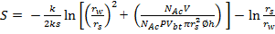 (1)
With no damaged or the wormholes penetrating beyond the damaged region
(2)
Equation 1 and 2 give the skin factor which consist of original permeability (k), permeability in damaged zone (k_{s}), skin radius (r_{s}), acid capacity number (N_{Ac}), acid volume per unit thickness (v/h), and number of pore volume at break through time (PV_{bt})
Acid Fracturing
The design of an acid fracturing treatment is designed in 650 ft of formation thickness with HCl 15% in limestone reservoir on 60 minutes to stimulate production from carbonate formations involves the following six steps: Step 1, Select an appropriate candidate and determine the current status of the well. Step 2, Determine formation rock and contained fluid properties such as formation thickness, permeability, porosity, fracture gradient, Poisson’s ratio, formation temperature, fluid injection temperature, reservoir pressure, reservoir fluid viscosity, reservoir fluid compressibility, and reservoir fluid density. Step 3, Select variable parameters such as the type and viscosity of pad fluids, acid concentration and additives to be used, injection rate for the pad fluid and acid, and the required design volumes of the two fluids. Step 4, Predict the fracture width (w_{fw}), average fracture wide (w_{fw(avg)}), fracture length (L_{f}) and the acid penetration distance for the fracturing fluid and selected acid from equation (3) to (5). Step 5, Predict the fracture conductivity and the expected stimulation ratio for pad and acid volumes to be injected. Step 6, Repeat step 3 to 5, varying parameters until a most economic and optimum acid treatment design is achieved.
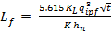 (3)
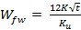 (4)
(5)
The relevant parameters to calculate fracture geometry are dimensionless (K_{u}, K_{L}), pad fluid injection rate (q_{ipf}), and net thickness (h_{n}). Stimulation ratio (J_{s}/J_{o}) after acid fracturing is determined by equation 6 which consists acid penetration distance (xL), expected fracture conductivity (W_{kf}), and gross and net thickness (h_{g}, h_{n}).
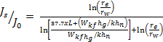 (6)
The geometry of acidizing and acid fracturing are shown in Figure 1..
Reservoir Efficiency
The reservoir efficiency program is used for analyzing the behavior of petroleum reservoir system. The concept and techniques of flow equation in porous media and circular pipe are applied creating tank model. Tank model is designed for 291.37 MMMSCF gas in place, 650 feet thickness, and 5 production wells. It covers area about 300 Acres. The top structure of model is at 8,500 feet depth. The process of this section will receive permeability from original reservoir permeability, after acidizing, and acid fracturing. The step of tank model starts from finding maximum production rate in 3 cases and gas production rate in each time steps.
Reservoir Simulation Model design
The performance prediction of reservoir after acid stimulation for the gas fields in the northeastern Thailand from the ECLIPSE OFFICE simulator (Schlumberger, 2013). Three cases of gas field properties base on original, acidizing, and acid fracturing properties are modeled with the gas in place of 225 MMMSCF respectively. Reservoir produced with no injection through the production period 20 year by 5 production wells. The reservoir model cover area sizes 15,000 x 9,000 ft² and 670 ft of thickness. Reservoir dimension are 25, 21, 10 grids (5,250 grid blocks). The top structure of model is at 9,000 feet depth as shows in Figure 2. The data of equilibration and fluid properties are as following

- Datum depth, (ft) 9,000
- Pressure at datum depth, (psi) 6,500
- Water/Oil contact depth, (ft) 10,000
- Water FVF at P_{ref} (rb/stb) 1.02135
- Water comp. (psi⁻¹) 2.925239x10⁻⁶
- Water viscosity (cp) 0.2917606
- Water viscosibility (psi⁻¹) 5.95587x10⁻⁶
- Gas dens. at surface (lb/ft³) 0.036832

The distribution of permeability development after stimulation which filled in reservoir model of each case is shown in Table 1. In the Figure 3 shows the vertical permeability developments of some wells in each case.
Results and Discussions
The important factors of acidizing are acid type, concentration and time. Spending time 200 minutes of hydrochloric acid 28% in limestone reservoir is used to be a case study. Permeability of reservoir at 50 ft of acidizing radius increases from 0.15 to 1.75 md (Table 2). This stimulation requires acid injection rate 7,345 gal/min, 5,876 gallons of acid volume per unit thickness to get skin factor equal to -4.
Tank model is used to determine flow rate of reservoir after acidizing compare with natural flow. Gas flow rate slightly increases 8.70% from 19.11 to 20.77 MMSCF/D (Figure 4) with initial flowing pressure of 6,500 psia but gas can be produced at constant rate for a year after acidizing. The production rate slightly decline after first year until the end of 20th years at 5.78MMSCF/D and 948 psia flowing pressure.
Cumulative gas production (Figure 5) at the 20th year is 91,283 MMSCF which increase about 19.71% from 76,251 MMSCF. After acidizing recovery factor increases about 19.71% from 26.17% (natural flow) to 31.33%.
The importance factor of acidizing are acid type, concentration and pumping horse power. The acid fracturing process is designed in 650 ft of formation thickness with hydrochloric 15% in limestone reservoir. This process requires pumping horse power 590 hp, minimum acid volume 273 ft³ and totals fluid volume (acid and pad fluid) 14,013 ft³. Vertical fracture size 151 ft x 0.07 in. of length and width is produced under surface 8,500 ft. This process increases permeability higher from 0.5 to 37.73x10⁹md (Table 2).
Gas flow rate after acid fracturing is determined by Tank model to compare with natural flow. Gas flow rate highly increases 1,096% from 19.11 to 228.46 MMSCF/D (Figure 4). Gas production rate is produced at constant rate for 3 years before decline immediately next 2 years before slightly decline until the 20th year at rate 2 MMSCF/D and 775.3 psia flowing pressure.
Cumulative gas production (Figure 5) at the 20th year is 273,106 MMSCF increased about 258.17% from 76,251 MMSCF. After acid fracturing recovery factor increases about 258.17% from 26.17% (natural flow) to 93.73% as a result of gas in place remaining about 18,265 MMSCF.
The reservoir parameters and acid stimulation results were also modeled by using Eclipse 100 (Schlumbeger) and gave much closed production performance comparison with the Tank model. The results of reservoir simulation are shown in Figure 6 to 8.
Economic Evaluation
The economic evaluation is used to analyze project investment possibility including of the profit investment ratio (PIR) and internal rate of return (IRR). The petroleum economic studies under the concession system and petroleum economics evaluation of Thailand III (Department of Mineral Resource, 1999) has assumption and detail that into basic assumptions add other assumptions cost as follows.
Gas price ($/1,000 SCF) 7.00
Exchange rate (Baht/$) 30.00
Income tax (%) 50
Escalation factor (%) 2
Discount rate (%) 10
Tangible cost (%) 20
Intangible cost (%) 80
Depreciation of tangible cost (%) 20
The expense used in cash flow analysis is listed in Table 3.
The results of economic evaluation with 5 production wells are shown in Table 4. The results of economic evaluation in case of natural flow (Table 4.) shows the total study worth of 20th years of Tank model which is natural flow process. The total worth is divided in to gross sale income 16,013 M baht and total cost 8,950 M baht. The internal rate of return no discount as equal to 0.45%. The cash flow still be minus until at the end of year production
The results of economic evaluation in case of natural flow (Table 4.) shows the total study worth of 20th years of Tank model which is natural flow process. The total worth is divided in to gross sale income 16,013 M baht and total cost 8,950 M baht. The internal rate of return no discount as equal to 0.45%. The cash flow still be minus until at the end of year production
The cash flow analysis after acidizing process shows the total study worth of 20th years of Tank model. The total worth is divided in to gross sale income 19,169 M baht and total cost 9,950 M baht. The internal rate of return no discount as equal to 1.84%. Although, stimulated by acidizing to get higher production rate, this method is not enough to get better production rate. The production rate increased a little as the results of income that the cash flow still is minus value until at the end of year production
After stimulated reservoir by acid fracturing and used the results to calculate cash flow show the better results. From total of cash flow analysis shows the total study worth of 20th years of Tank model which is flow after fracturing. The total worth is divided in to gross sale income 57,352 M baht and total cost 10,750 M baht. The high production rate in 1st to 3rd year has an effect to increasing of income and slightly decline after the end of 3rd year. The natural gas production has completely paid back in the 6th year of production with internal rate of return around 35%.

Conclusions and Recommendations
Well stimulation by acid is calculated from acid stimulation program. In the part of well stimulation, in this study reservoir model is carbonate reservoir with acidizing and acid fracturing to increase permeability and production rate. The important factors of acidizing are acid type, acid concentration, and time. Hydraulic horse power and acid types are important factor of acid fracturing.
At the same condition, acid fracturing gives higher value of permeability than acidizing and natural flow. Production rate is increased highly after stimulated acid fracturing followed by acidizing about 1,096 and 8.7%, respectively from 19.11 MMSCF of natural flow.
The cash flow table in Table 3 can be concluded that stimulation by acid fracturing shows the highest IRR is 34.49%, and paid back period at 6th year. Acidizing and natural flow will not be economically produced because the internal rate of return is small and minus.
The results of gas production performance from developed program and Eclipse show the closed results. Acid stimulation program are advantage valuable data to use for decision-making in the investment of petroleum exploration, production in the other petroleum prospects in the northeastern Thailand and useful in the prediction of the future petroleum business in the northeastern Thailand.

Acknowledgement
The research work presented in this paper was supported by Suranaree University of Technology. The authors would like to thank Assoc. Prof. Kriangkrai Trisarn for his valuable suggestions.

References
Al-Dahlan, M. N., Nasr-El-Din H. A., and Saudi Aramco. (2000). Acid Treatments in Carbonate Reservoirs, SPE International Symposium on Formation Damage Control, Lafayette, Louisiana.
Bazin, B., and Longeron, D., (2000). Institut Français du Pétrole. Carbonate Acidizing: A Physical Simulation of Well Treatments, [on-line]
Available:http://www.scribd.com/doc/9844387/Carbonate-Acidizing-A-Physical-Simulation-of-Well-Treatments.
Crowe, C. W., (1981) Evaluation of Acid Gelling Agents for Use in Well Stimulation, Society of Petroleum Engineers Journal. 415.
Department mineral and fuels, (2006), Final report petroleum assessment in northeastern Thailand, Department of mineral and fuels advisory contract No. 22/2006, Thailand.
Economides, M. J., Daniel A. H., (1994), Petroleum Production Systems. Englewood Cliffs, NJ: Prentice Hall.
Economides, M. J. and Nolte, K. G., (2000) Reservoir Stimulation 3rd ed. Schlumberger Education Service.
Kalfayan, L., (2001). Production Enhancement with Acid Stimulation, First edition, Penwell Coporation Tulsa, Oklahoma.
Mian M. A., (1992). Petroleum Engineering Hand Book for the Practicing Engineer, volume II, Tulsa, Oklahoma.
Trisarn, K. (2003). Acid Fracturing Increase Production in Tight Gas Carbonate The PTTEP Technical Forum, Rajpruck Club, Bangkok

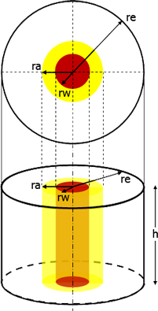
Acidizing
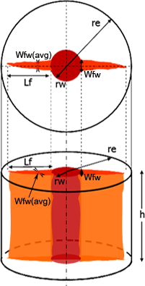
Acid fracturing

Figure 1. Geometry of acid stimulation in a finite reservoir

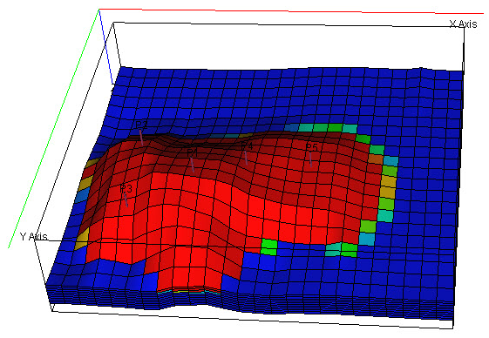
X-Axis
Y-Axis
Z-Axis
P1
P2
P3
P4
P5
Figure 2. Oblique view of structure

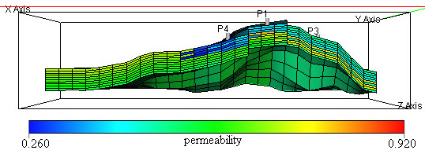
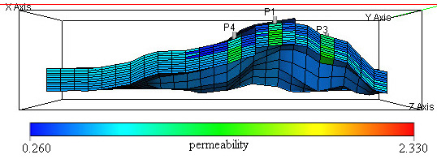

a) Original permeability b) Permeability (acidizing)
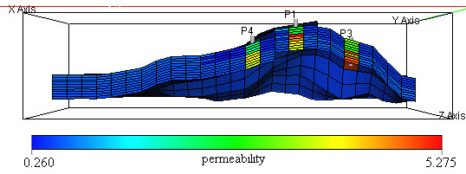

c) Permeability (acid fracturing)
Figure 3. Permeability distribution of cross-section structure

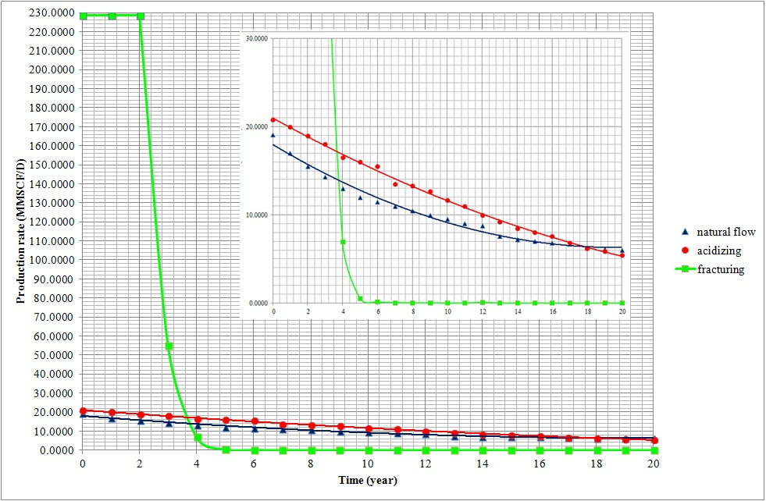
Figure 4. The relationship between production rate and time

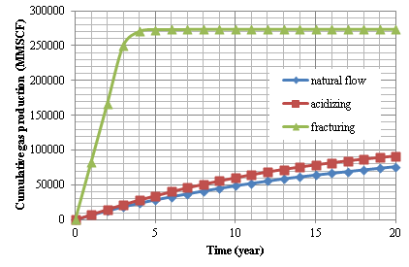
Figure 5. The relationship between cumulative production rate and time

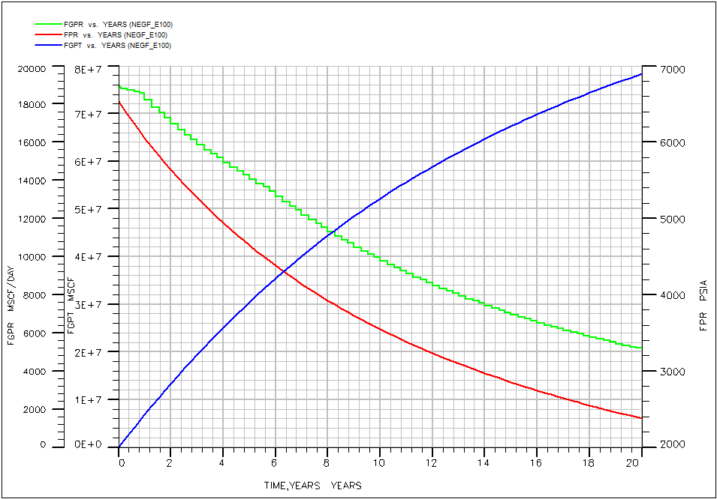
Figure 6. Result of simulation by natural flow

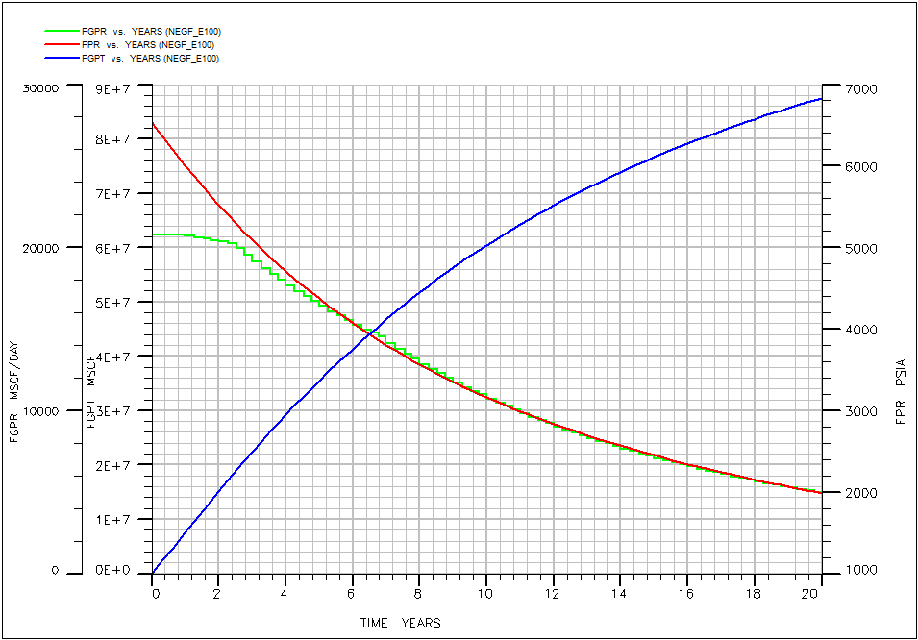
Figure 7. Result of simulation after stimulation by acidizing

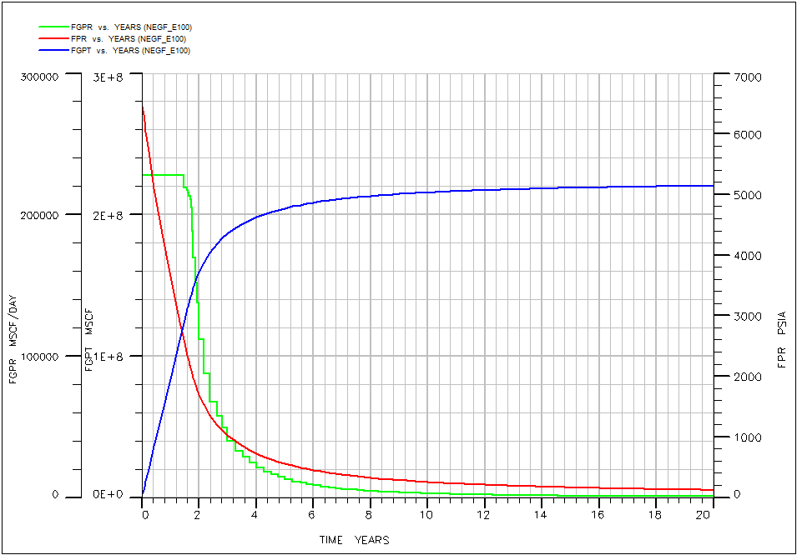
Figure 8. Result of simulation after stimulation by acid fracturing

Table 1. The development of average permeability after stimulation
Well No. | Layer | Original K | Acidizing | Acid fracturing | Well No. | Layer | Original K | Acidizing | Acid fracturing
Well No. | Layer | (md) | Avg. K (md) | Avg K (md) | Well No. | Layer | (md) | Avg. K (md) | Avg K (md)
P1 | 1 | 0.4 | 0.94 | 2.64 | P4 | 1 | 0.3 | 0.78 | 1.98
P1 | 2 | 0.39 | 0.92 | 2.57 | P4 | 2 | 0.39 | 0.92 | 2.57
P1 | 3 | 0.38 | 0.91 | 2.51 | P4 | 3 | 0.28 | 0.75 | 1.85
P1 | 4 | 0.8 | 1.35 | 5.27 | P4 | 4 | 0.36 | 0.88 | 2.37
P1 | 5 | 0.71 | 1.28 | 4.68 | P4 | 5 | 0.63 | 1.2 | 4.15
P1 | 6 | 0.7 | 1.27 | 4.62 | P4 | 6 | 0.62 | 1.2 | 4.09
P1 | 7 | 0.62 | 1.2 | 4.09 | P4 | 7 | 0.61 | 1.19 | 4.02
P1 | 8 | 0.6 | 1.18 | 3.96 | P4 | 8 | 0.6 | 1.18 | 3.96
P1 | 9 | 0.58 | 1.16 | 3.82 | P4 | 9 | 0.54 | 1.11 | 3.56
P1 | 10 | 0.56 | 1.13 | 3.69 | P4 | 10 | 0.58 | 1.16 | 3.82
P2 | 1 | 0.5 | 1.07 | 3.3 | P5 | 1 | 0.7 | 1.27 | 4.62
P2 | 2 | 0.48 | 1.04 | 3.16 | P5 | 2 | 0.69 | 1.26 | 4.55
P2 | 3 | 0.47 | 1.03 | 3.1 | P5 | 3 | 0.68 | 1.25 | 4.48
P2 | 4 | 0.45 | 1.01 | 2.97 | P5 | 4 | 0.65 | 1.22 | 4.29
P2 | 5 | 0.44 | 0.99 | 2.9 | P5 | 5 | 0.63 | 1.2 | 4.15
P2 | 6 | 0.78 | 1.33 | 5.14 | P5 | 6 | 0.62 | 1.2 | 4.09
P2 | 7 | 0.48 | 1.04 | 3.16 | P5 | 7 | 0.6 | 1.18 | 3.96
P2 | 8 | 0.76 | 1.32 | 5.01 | P5 | 8 | 0.59 | 1.17 | 3.89
P2 | 9 | 0.72 | 1.28 | 4.75 | P5 | 9 | 0.58 | 1.16 | 3.82
P2 | 10 | 0.5 | 1.07 | 3.3 | P5 | 10 | 0.6 | 1.18 | 3.96
P3 | 1 | 0.5 | 1.07 | 3.3
P3 | 2 | 0.48 | 1.04 | 3.16
P3 | 3 | 0.47 | 1.03 | 3.1
P3 | 4 | 0.45 | 1.01 | 2.97
P3 | 5 | 0.44 | 0.99 | 2.9
P3 | 6 | 0.78 | 1.33 | 5.14
P3 | 7 | 0.48 | 1.04 | 3.16
P3 | 8 | 0.76 | 1.32 | 5.01
P3 | 9 | 0.72 | 1.28 | 4.75
P3 | 10 | 0.75 | 1.31 | 4.94

Table 2. Reservoir efficiency results with 5 production wells
Reservoir efficiency | Natural flow | Acidizing | Acid fracturing
Permeability in stimulated zone, md. | 0.5 | 1.76 | 37.73x10⁹
Maximum production rate, MMSCF/D | 19.108 | 20.769 | 228.456
Initial gas in place, MMMSCF | 291.371 | 291.371 | 291.371
Time of constant rate, month | 1.198 | 13.00 | 36.00

Table 3. Cash flow expenditure cost detail.
Expenditure Cost Detail NE Model | Expenditure Cost Detail NE Model
Concession (Baht) | 150,000,000
Geological and geophysical (Baht) | 400,000,000
Exploration and apprisal wells (Baht) | 1,200,000,000
Production wells without well stimulation(Baht/Well) | 240,000,000
Production wells with acidizing (Baht/Well) | 360,000,000
Production wells with acid fracturing (Baht/Well) | 600,000,000
Pipelines and processing production facilities (Baht) | 6,000,000,000
Operation cost (Baht/MMSCF) | 2,000
Fixed operation cost (Baht/year) | 150,000,000

Table 4. Economic evaluation results summary with 5 production wells.
 | Natural flow | Acidizing | Acid fracturing
Gas in place, SCF | 291,371,240,000 | 291,371,240,000 | 291,371,240,000
Cumulative gas production, SCF | 76,251,100,000 | 91,283,200,000 | 273,105,800,000
Exchange rate, Baht/$ | 30.00 | 30.00 | 30.00
Gas price, $/1,000 SCF | 7.00 | 7.00 | 7.00
Income, bath | 16,012,731,000 | 19,169,472,000 | 57,352,218,000
Royalty, baht | 800,636,550 | 997,536,750 | 8,331,963,150
Operation cost, baht | 3,016,079,643 | 3,019,167,672 | 3,050,445,982
Total allow expense+SRB, baht | 12,766,716,193 | 13,566,704,422 | 22,529,862,883
Taxable income after SRB, baht | 3,246,014,807 | 5,602,767,578 | 34,822,355,117
Income tax, baht | 2,978,007,404 | 4,396,383,789 | 19,486,177,558
Annual cash flow, baht | 268,007,404 | 1,206,383,789 | 15,336,177,558
Discounted cash flow, baht | -2,485,729,191 | -2,333,337,153 | 7,295,300,184
Total investment, baht | 8,950,000,000 | 9,550,000,000 | 10,750,000,000
Profit to investment Ratio (PIR) | 0.03 | 0.13 | 1.43
Net cash flow10%Discount(Baht), baht | -2,485,729,191 | -2,333,337,153 | 7,295,300,184
Internal rate of return (IRR) 10%disc. | -8.68% | -7.42% | 34.49%
Profit to Investment Ratio (PIR) | -0.40 | -0.35 | 0.97
Payout period, year | - | - | 6.00
IRR no discount | 0.45% | 1.84% | 47.94%

*

